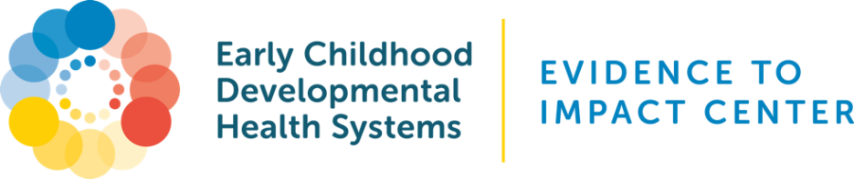

Sample Guide for Embedding the Promoting Healthy Development Survey (PHDS) Into Post-Visit Workflows

Embedding PHDS in Paper-Based Workflows

When to Use:
  - For clinics without a fully integrated electronic health record (EHR) or limited IT capacity.
  - As part of check-out or follow-up packet.

How to Implement:
- Distribute at Check-Out:
  - Hand the survey to families as they leave a well-child visit.
- Attach to Visit Summary:
  - Include PHDS in printed after-visit summary materials.
- Set Up Collection System:
  - Provide drop-boxes at front desk or waiting room for anonymous return.
- Staff Follow-Up:
  - Call or text families after the visit to complete PHDS on paper or over the phone.
- Translate Forms:
  - Offer PHDS in the family’s preferred language.

Embedding PHDS Into EHR Workflows (Post-Visit)

When to Use:
- EHRs with patient portal or survey delivery capabilities (e.g., Epic MyChart, Athenahealth, eClinicalWorks).

How to Implement:
- Build into EHR Workflow:
  - Add a smart phrase or trigger in the after-visit summary (AVS) to include a PHDS link or QR code.
  - Include the PHDS link in appointment reminder follow-ups sent 1-3 days post-visit.
- Use the Patient Portal:
- Send PHDS through secure messaging via the patient portal.
- Automate reminders for completion after specific well-visit types.
- Integrate via API or Embed Code:
- If supported, embed a secure PHDS link or iframe in the post-visit dashboard.
- Work with IT or your EHR vendor to ensure data privacy.
- Track Completion and Feedback:
- Set up a reporting system to monitor response rates.
- Review aggregated feedback regularly for quality improvement.

Best Practices for Integration
- Inform Families: Let caregivers know their feedback helps improve care.
- Limit Burden: Make the process simple with a link, QR code, or drop-off option.
- Incentivize Participation: Offer small incentives or raffle entries.
- Close the Loop: Share “You said, we did” summaries to build trust and engagement.

