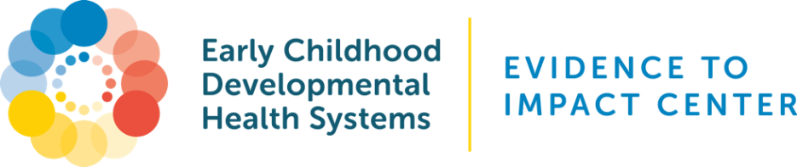

Sample Training Module: Implementing Family Care Transition Planning

Audience: Providers, Care Coordinators, Early Childhood Specialists

Duration: 30-45 minutes

Format: Brief presentation + case discussion + Q&A

Learning Objectives:
1. Understand the purpose and principles of family-centered care transition planning.
2. Navigate and use the Family Care Transition Plan template effectively.
3. Facilitate meaningful family engagement in planning.
4. Coordinate formal and informal supports for successful transitions.

Part 1: Why Family Care Transition Planning Matters

Definition: A structured approach to supporting families through transitions (e.g., developmental stages, provider changes, program exits).

Why it’s important:
- Prevents gaps in care
- Reduces family stress
- Builds independence and long-term stability

Who it’s for: Children and families facing care shifts due to age, health, or setting changes.

Part 2: Overview of the Transition Plan Template

Key Sections:
I. Family’s Goals – Captures family-defined short- and long-term goals
II. Action Steps – Identifies who will do what and by when
III. Preferences – Ensures linguistic and scheduling needs are honored
IV. Formal Supports – Names professional contacts and services
V. Informal Supports – Acknowledges natural support networks (e.g., relatives, friends)
VI.-VII. – Documents additional needs and signatures
Part 3: Protocol & Workflow

Step-by-Step Guide:
1. Identify Transition Point – Age-based or system change
2. Schedule a Transition Planning Meeting – Include all relevant participants
3. Facilitate Collaborative Completion of the Template – Start with goals, co-develop actions, document supports
4. Assign Follow-Up Roles – Define who checks on each action item
5. Store & Share the Plan – Save in electronic health record or system and share with family
6. Review & Update – Regularly review and update (e.g., every 6 months)

Part 4: Case Example & Practice
Scenario: A 3-year-old child transitioning from early intervention to a preschool special education program.

Discussion Points:
- What are short-term and long-term goals?
- What informal supports could be involved?
- What role will the care coordinator play?

Part 5: Q&A and Discussion
- Barriers to implementation?
- What support do teams need to integrate this into daily workflow?

